White Water Website Plan

1. The Site Logo.

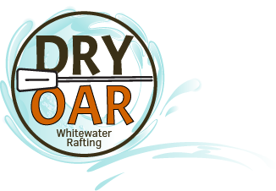

1. Color Code for the website
2. Primary color - #D5BDAF
3. Secondary color - #E3D5CA
4. Accent1 color -#EDEDE9
5. Accent2 color – #F5EBE0
6. Font names
7. Heading font - Montserrat
8. Text font – Roboto
9. the URL of your color palette from coolors.co: https://coolors.co/palette/edede9-d6ccc2-f5ebe0-e3d5ca-d5bdaf